ETIS - Use Case and Class Diagrams
Task 3 - Semester project models (10 marks)
Student: Atta ur Rehman | Reg. No.: BSSE-011 | Section 5A
Course: Software Development & Architecture (SDA) | Project: ETIS

1. Use Case Diagram
Actors: Admin (exam cell), Teacher/Invigilator, Student, and the external Nager.Date Holiday API. «include» means the base use case always uses the other; «extend» means optional behaviour triggered under a condition.
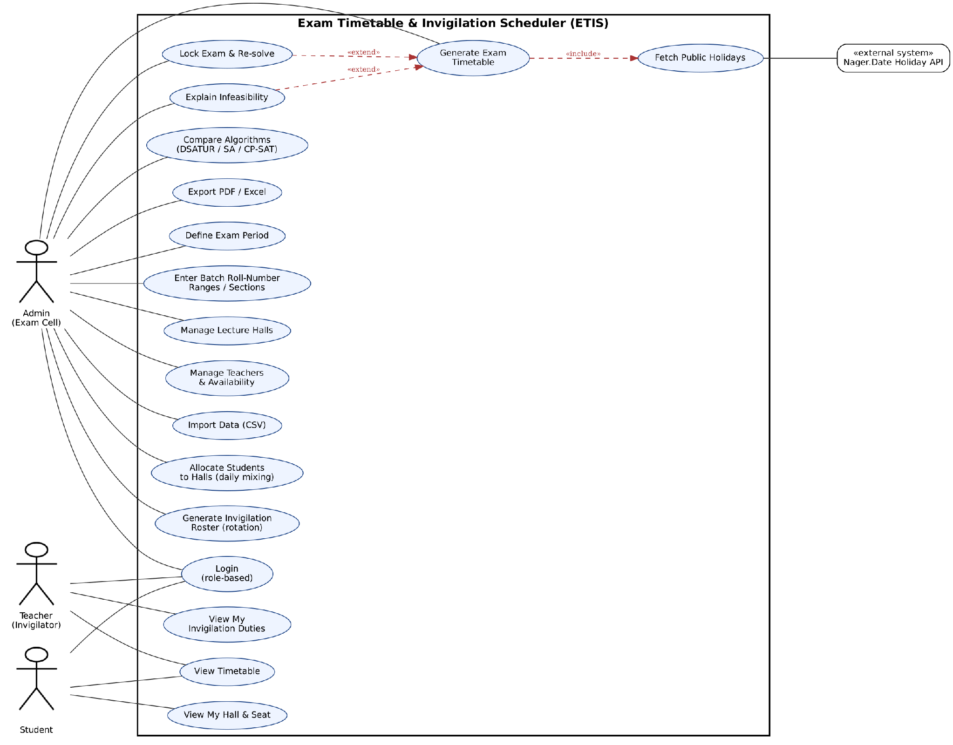
Figure 1: ETIS use case diagram

Use case descriptions
Use case | Actor | Description
Login (role-based) | All users | User signs in with a bcrypt-hashed password; the role (Admin/Teacher/Student) decides what is shown.
Define Exam Period | Admin | Enter start/end dates and slots per day.
Enter Batch Roll-Number Ranges | Admin | Give ranges per section (e.g. F24-BSSE-001 to 050 = A); students are generated automatically.
Manage Lecture Halls / Teachers | Admin | Add halls with capacities; add teachers with availability.
Import Data (CSV) | Admin | Bulk-load halls, teachers, courses and enrolments.
Generate Exam Timetable | Admin | Run the solver (DSATUR -> CP-SAT) to create a clash-free timetable. Includes Fetch Public Holidays.
Allocate Students to Halls | Admin | Daily student-to-hall allocation with mixing; reports % students moved.
Generate Invigilation Roster | Admin | Rotating, fair invigilator duties; no duty in own course.
Explain Infeasibility «extend» | Admin | If generation fails, list the small set of conflicting constraints.
Lock Exam & Re-solve «extend» | Admin | Fix an exam, re-run the solver for the rest after a last-minute change.
Compare Algorithms | Admin | Run DSATUR, SA and CP-SAT and compare violations, penalty, runtime.
Export PDF / Excel | Admin | Download datesheet, hall allocation and duty roster.
Fetch Public Holidays | Nager.Date API | Provides holidays to exclude; falls back to a local CSV.
View Timetable | Student, Teacher | See the published datesheet.
View My Hall & Seat | Student | See only own hall and seat per day.
View My Invigilation Duties | Teacher | See only own duties.

2. Class Diagram - Domain Model
Main entities of ETIS: users and roles, batch/section/student structure, courses, exams, time slots, halls, and the generated timetable with its hall allocations and invigilation duties.
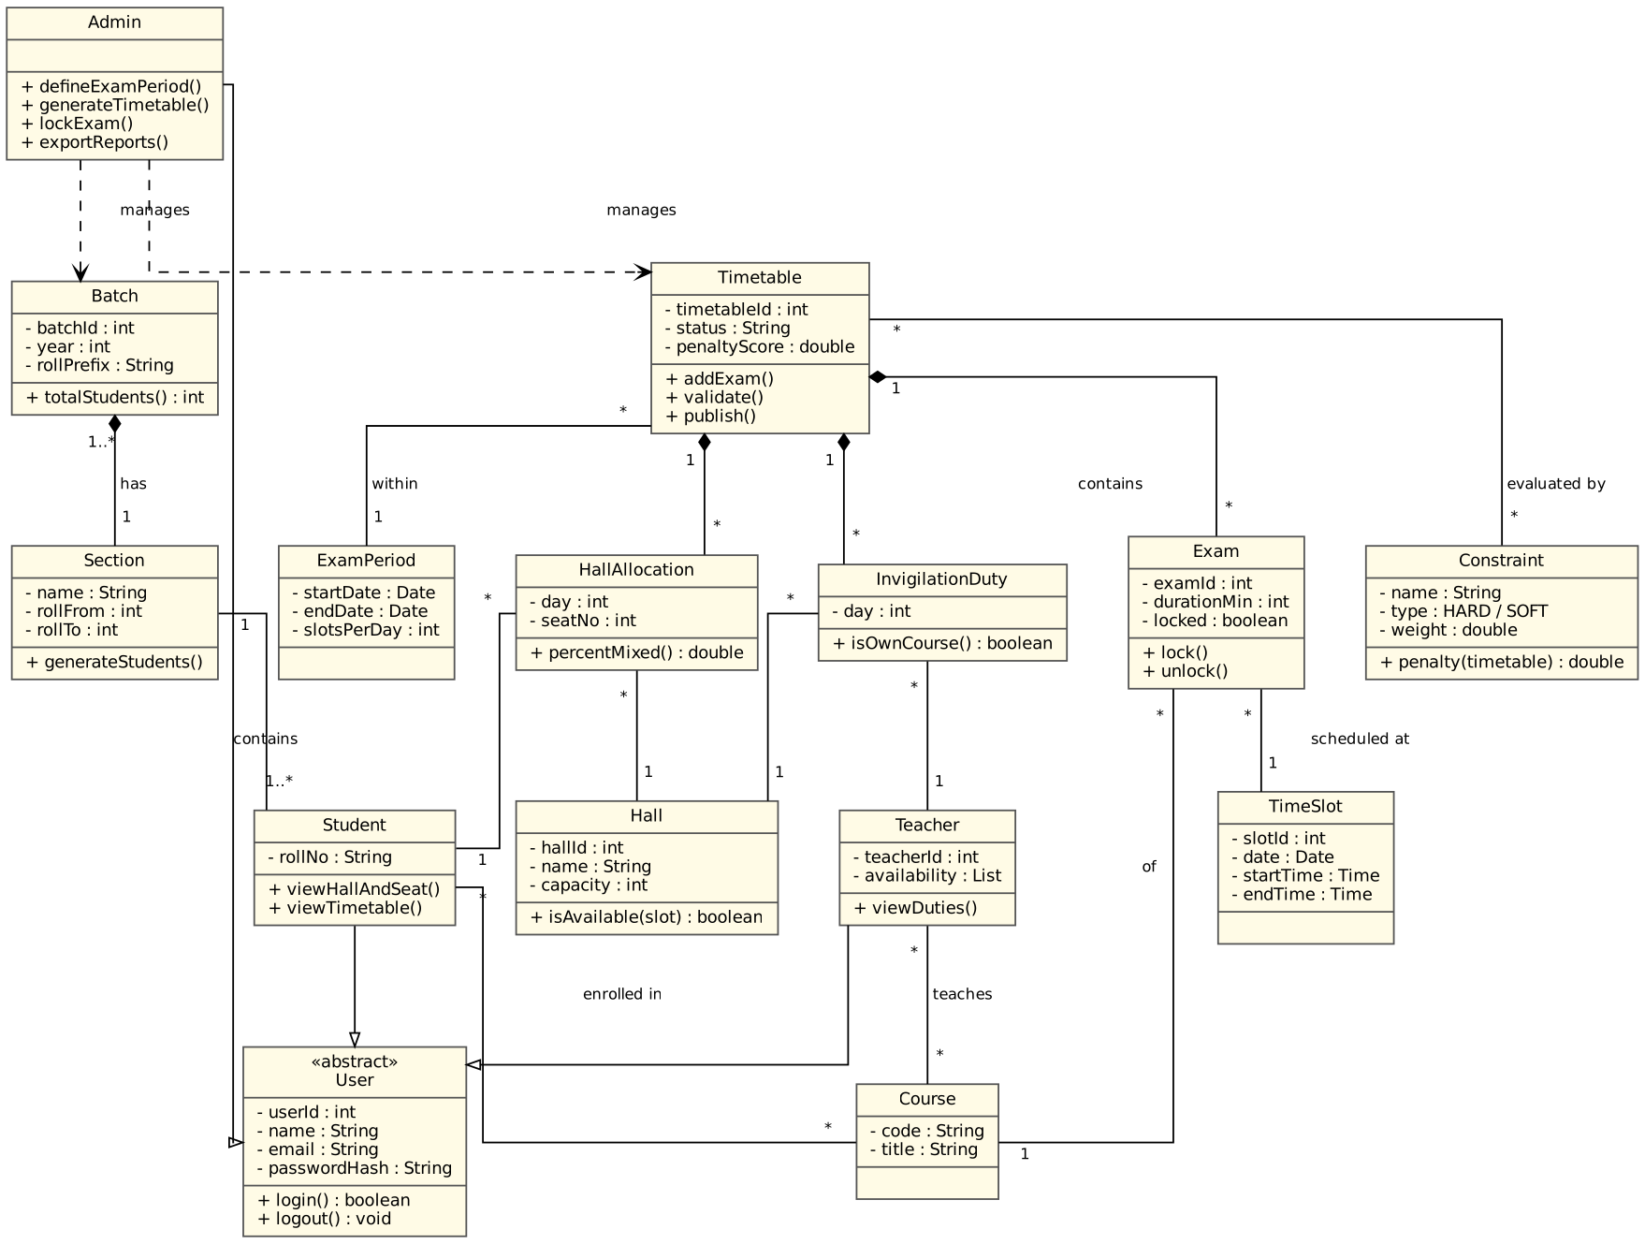
Figure 2: ETIS domain class diagram
Relationships: Admin, Teacher and Student inherit from User; Batch is composed of Sections, each containing Students; a Timetable is composed of Exams, HallAllocations and InvigilationDuties and is evaluated by weighted hard/soft Constraints.

